United Nations Sustainable Development Goals (SDG)
Goal ONE – End Poverty
A. Ending poverty in all its forms remains one of the greatest challenges facing humanity. The number of people living in extreme poverty dropped by more than half between 1990 and 2015, but too many are still struggling for the most basic human needs.

B. In 2015, about 736 million people still lived on less than US$1.90 a day. Many of those lack food, clean drinking water and washing facilities. Very fast growth in countries such as China and India has lifted millions out of poverty, but progress has been uneven. Women are more likely to be poor than men because they have less paid work, education, and own less property.

C. Progress has also been limited in other regions, such as South Asia and sub-Saharan Africa, which account for 80 percent of those living in extreme poverty. New threats brought on by climate change, conflict and access to food, mean even more work is needed to bring people out of poverty.

D. The SDGs are a strong commitment to finish what we started, and end poverty in all forms and dimensions by 2030. This involves targeting the most weak and vulnerable, increasing basic resources and services, and supporting deprived communities affected by conflict and climate-related disasters.

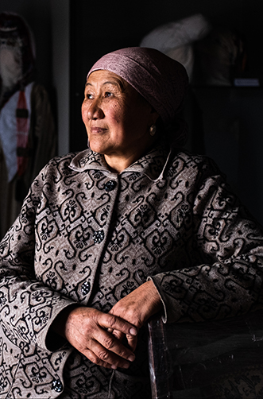

10% of the world’s population lives in extreme poverty. Down from 36 % in 1996.
1.3 billion people live in multidimensional poverty.
Half of all people in poverty are under 18
1 in every 10 people is extremely poor.
736 million people still live in extreme poverty

Goal Targets
- By 2030, reduce at least by half the proportion of men, women and children of all ages living in poverty in all its dimensions according to national definitions
- Implement nationally appropriate social protection systems and measures for all, and by 2030 achieve substantial coverage of the poor and the vulnerable
- By 2030, ensure that all men and women, in particular the poor and the vulnerable, have equal rights to economic resources, as well as access to basic services, ownership and control over land and other forms of property, inheritance, natural resources, appropriate new technology and financial services
- By 2030, build the strength of the poor and those in vulnerable situations and reduce their exposure and vulnerability to climate-related extreme events and other economic, social and environmental shocks and disasters
- Ensure significant gathering and collection of resources from a variety of sources, including through enhanced cooperation, in order to provide adequate and predictable means for developing countries, in particular, least developed countries, to implement programmes and policies to end poverty in all its dimensions
- Create efficient policy frameworks at the national, regional and international levels, to support quicker investment in poverty actions that will end poverty

